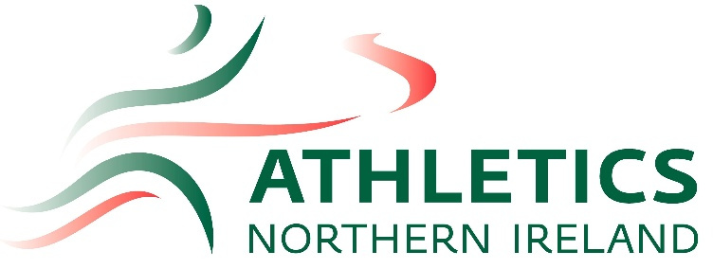

NI & Ulster 10k Championships
&
ANI Open Meet

Mary Peters Track, Belfast
30th May 2026

11.00am REGISTRATION

Track
12:00pm | Men’s & Women’s 10,000m NI & Ulster Championships
1:30pm | U16 Girls 100m
1:40pm | U14 Boys 100m
1:45pm | U14 Girls 100m
1:50pm | U18 & Senior Women 100m
2:00pm | U16, U18 & Senior Men 100m

Field
11.30am | U16, U18 & Senior Men’s Javelin
12:30pm | U16 Girls Javelin
1:30pm | U14 & U16 Boys & U18 & Senior Men’s High Jump
2:30pm | U14 & U16 Girls & U18 & Senior Women’s High Jump

